

SIMATS ENGINEERING
Saveetha Institute of Medical and Technical Sciences Chennai- 602105

Student Name: K.Tejaswi Reg. No: 192525407
Course Code: CSA0924 Slot: B
Course Name: Database management systems
Course Faculty: Jaya Mabel Rani

Project Title: Iot Based Smark Parking Management System Using Er Modeling And Relational Database Design
Module Photographs:
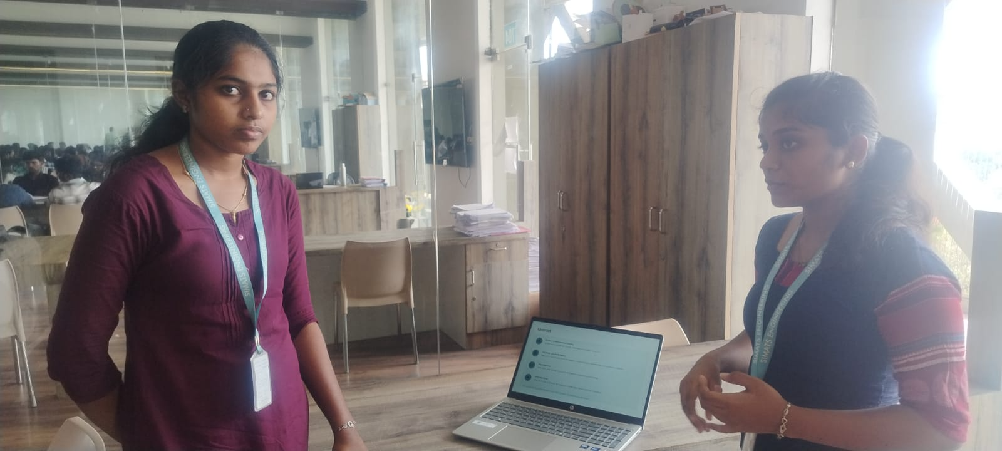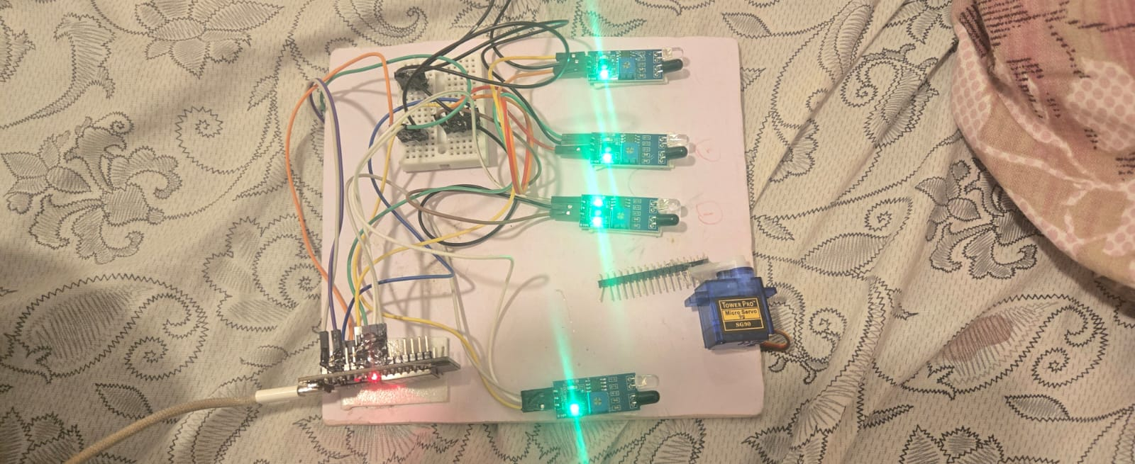

Project Description:
Module 1 – Hardware & IoT Data Acquisition
The IoT-based Smart Parking Management System integrates hardware sensors, microcontrollers, and real-time data acquisition to efficiently monitor and manage parking slots. This module focuses on the hardware setup and IoT data flow, ensuring accurate detection and seamless communication with the database.
- IR Sensors: Each parking slot is equipped with an infrared sensor to detect vehicle presence. A vacant slot registers no obstruction, while an occupied slot triggers detection.
- ESP32 Microcontroller: Acts as the central processing unit, collecting sensor signals, processing them, and transmitting data via built-in Wi-Fi.
- Wi-Fi Data Transmission: Sensor readings are sent to the relational database, enabling ER-modeled storage of slot status and transactions.
- LCD 16×2 Display: Shows the number of available slots in real time, providing immediate feedback to drivers.
- LED Indicators: Each slot is marked with LEDs—green for vacant, red for occupied—offering a clear visual guide.
- Servo Motor Gate Control: Automates entry and exit by opening or closing the parking gate when a vehicle is detected.
- Buzzer Alerts: Provides an audible signal when a vehicle enters, enhancing safety and awareness.
- Real-Time Monitoring: Continuous updates ensure accurate slot availability, supporting efficient parking management.
This hardware and IoT acquisition layer forms the foundation of the system, feeding structured data into the relational database designed using ER modeling. The database schema captures entities such as ParkingSlot, Vehicle, and Transaction, enabling reliable queries, reporting, and integration with higher-level modules like analytics and user applications.

Student Signature Guide Signature

